

**ACSG**

**Mentoring Program**

**ACSG Mentoring Program**

**Overview:**

The Asia Crisis and Security Group (ACSG) runs a mentoring programme for professionals looking to enter and develop their careers within the corporate security space. The programme is open to individuals at all levels and does not involve an enrolment fee. All mentors and mentees are required to be an ACSG member in one of the existing membership categories – Full membership, New Professionals in Corporate Security or ACSG Scholarship Programme.

The purpose of the mentoring programme is to provide an avenue for mentors to connect with and share experiences with their mentees. Mentors can help navigate mentees through their career by assisting them through professional challenges, skills development, identifying and moving to new roles, growing or developing in existing roles. In turn, mentors receive the benefit of new perspectives from their mentees, the opportunity to learn from their experiences and most importantly, an avenue to pay it forward by extending the benefit of their life experiences.

**General guidelines:**

* The mentoring programme is a six-month commitment, please consider this commitment before enrolling.
* Each mentor will be paired with one mentee.
* Mentors are encouraged to have a meeting with their mentees at least three times through this time period but can meet as many times as schedules permit. While in person meetings are encouraged (which we will take into consideration when matching the profiles) virtual methods of communication such as Skype and other messaging/conferencing tools can also be explored.
* Mentors and mentees will be required to complete an on-boarding and off-boarding form. The on-boarding form will allow us to match mentors with mentees, based on what each party is looking to derive from the programme. The off-boarding programme will allow us to understand the value derived from the mentoring programme and future opportunities.
* Ultimately, the mentoring programme is aimed at creating an opportunity to build a lasting relationship. The success of the relationship depends upon the programme’s participants and their commitment.
* Mentors and mentees will receive guidance and tools from the ACSG’s mentor program working group committee that could be used and attribute to the effectiveness of the program.
* Any areas of disconnect or escalations must be raised before the Steering Committee as early as possible and will be addressed in line with the ACSG Code of Conduct.

|  |  |  |
| --- | --- | --- |
| Mentor | All Participants | Mentee |

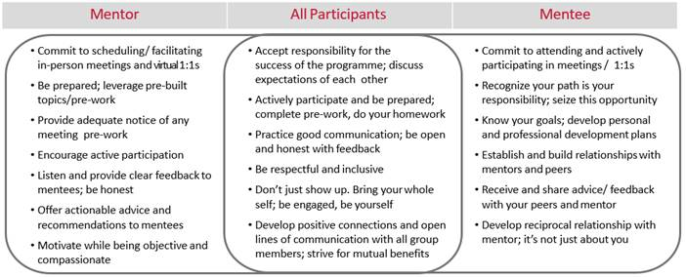

**Submissions:**

* The mentoring program will run from Jan to June and July to December each year.
* Completed application forms (001 or 002) to be submitted through the website on or before the date listed in the announcement email.
* Mentors and Mentees will be contacted direct in December and June.

